**Analysis on Red Wine Quality Prediction**

* **Objective:**

In this blog, I am going to explain my analysis on the famous **“Red Wine Quality Prediction”** with the help of the Machine Learning Model in which I will implement multiple predictions and further I will save the best model according to the final result that I will get from different analysis. With the help of these analysis, I will be able to get the information regarding the actual quality of the poor, normal or excellent wine.

* **Let’s talk about Red Wine:**



The **Red wine** is a sort of wine made from dark-colored grape varieties. The actual color of the wine can range from serious violet, common of youthful wines, through to block red for mature wines and brown for more established red wines. The juice from most purple grapes is greenish-white, the red shading coming from anthocyan shades (additionally called anthocyanins) present in the skin of the grape; exemptions are the moderately uncommon teinturier varieties, which produce a red-hued juice. A significant part of the red-wine creation process consequently includes the extraction of shading and flavor parts from the grape skin. **Red wine** is a delicacy all throughout the planet.

* **Let’s talk about Vinho Verde Wine:**

** **

**Vinho Verde** (in a real sense 'green wine') alludes to Portuguese wine that began in the historic Minho province in the furthest north of the country. The present day **'Vinho Verde'** locale, initially assigned in 1908, incorporates the old Minho region in addition to nearby regions toward the south. In 1976, the old area was disintegrated.

**Vinho Verde** isn't a grape assortment, it is a DOC for the creation of wine. The name signifies "green wine," however interprets as "youthful wine", with wine being delivered three to a half year after the grapes are harvested. They may be red, white, or rosé, and they are normally burned-through before long bottling. A **Vinho Verde** can likewise be a shimmering, a Late Harvest or even Brandy. In its initial long stretches of creation, the slight effervesce of the wine came from malolactic fermentation taking place in the jug. In winemaking this is typically considered a wine fault but **Vinho Verde** makers found that shoppers loved the somewhat bubbly nature. In any case, the wines must be bundled in opaque bottles to stow away the unseemly turbidity and dregs that the "in-bottle MLF" delivered. Today, most **Vinho Verde** makers presently don't follow this training with the slight shimmer being added by artificial carbonation.

The locale is described by its numerous little producers, which numbered around 19,000 starting at 2014. A considerable lot of these producers utilized to train their plants high off the ground, up trees, wall, and even telephone poles so that they could cultivate vegetable crops underneath the plants that their families might use as a food source.

* **Problem Statement:**

The dataset is related to red and white variants of the Portuguese "Vinho Verde" wine. Due to privacy and logistic issues, only physicochemical (inputs) and sensory (the output) variables are available (e.g. there is no data about grape types, wine brand, wine selling price, etc.).

This dataset can be viewed as classification task. The classes are ordered and not balanced (e.g. there are many more normal wines than excellent or poor ones). Also, we are not sure if all input variables are relevant. So it could be interesting to test feature selection methods.

* **Attribute Information:**

Input variables (based on physicochemical tests):  
01 - Fixed acidity  
02 - Volatile acidity  
03 - Citric acid  
04 - Residual sugar  
05 - Chlorides  
06 - Free sulfur dioxide  
07 - Total sulfur dioxide  
08 - Density  
09 - pH  
10 - Sulphates  
11 - Alcohol  
Output variable (based on sensory data):  
12 - Quality (score between 0 and 10)

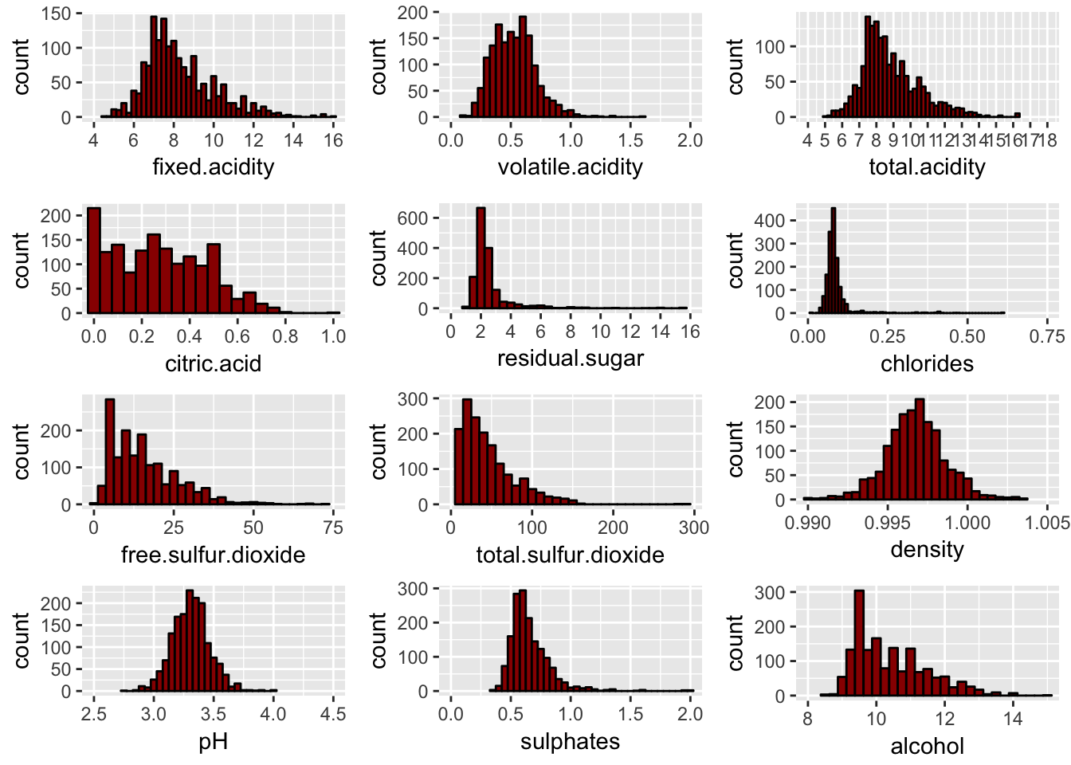

What might be an interesting thing to do, is to set an arbitrary cutoff for your dependent variable (wine quality) at e.g. 7 or higher getting classified as 'good/1' and the remainder as 'not good/0'.

Let’s begin my Analysis on **“Red Wine Quality Prediction”** dataset. Below you will find the way to do analysis on **“Red Wine Quality Prediction”**  dataset via Python.

* **Importing all the Required Libraries:**

First, I will import all the required libraries to start the analysis on the given data.

***# Importing all the required libraries***

***import numpy as np***

***import pandas as pd***

***import matplot.pyplot as plt***

***import seaborn as sns***

***import filterwarinings(“ignore”)***

After importing all the required libraries, I will get data from csv and start doing my analysis on it. Further, I will check various factors such as datatype, null values (i.e. missing values) to get more efficient analysis. If required, I will create additional columns for further analysis.

* **Getting the Data:**

***# Loading the data***

red_proj = pd.read_csv('winequality-red.csv')

***# Print the red wine dataset***

red_proj

Using above command, we can see the total number of entries. It is always good to look on the data before we start our analysis. It is very helpful and easy to understand.

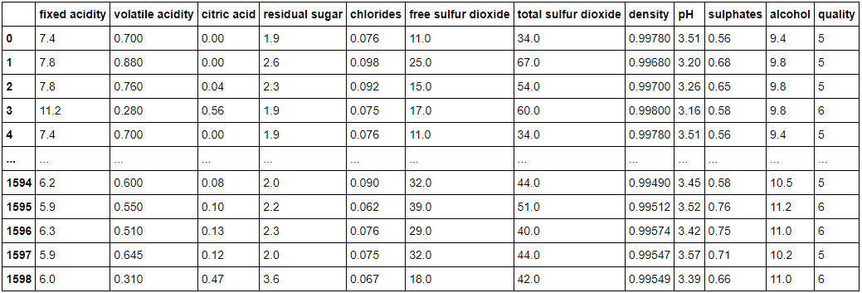

1599 rows × 12 columns

***# Getting total Column names***

red_proj.columns

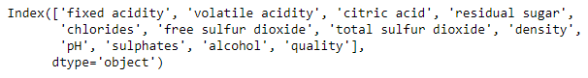

***# Get a total number of Rows & Columns***

red_proj.shape

(1599, 12)

From the above case, we can see that given data contains 1599 rows and 12 columns.

***# Checking for the Null values***

red_proj.isnull().sum()

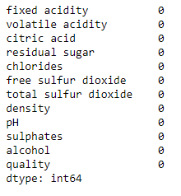

***# Let’s change the Quality to Categorical Data***

**for** i **in** range(0,1599):

**if** red_proj["quality"][i]>=7:

red_proj["quality"][i]=1

**else**:

red_proj["quality"][i]=0

Red_proj[“quality”]

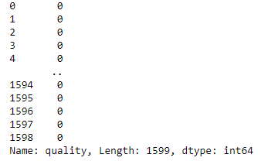

np.where(red_proj["quality"]==1)

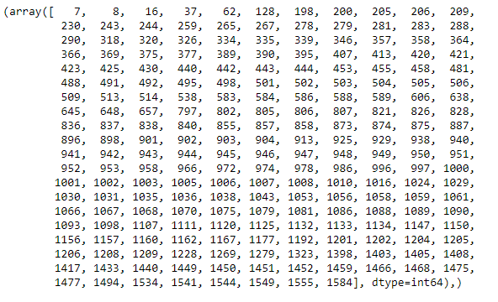

* **EDA**
* **Scatterplot:**

sns.scatterplot(x="fixed acidity", y="quality", data=red_proj)

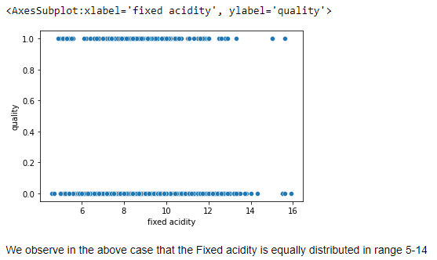

sns.scatterplot(x="volatile acidity", y="quality", data=red_proj)

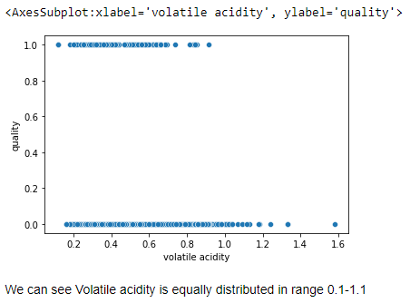

sns.scatterplot(x="citric acid" ,y="quality", data=red_proj)

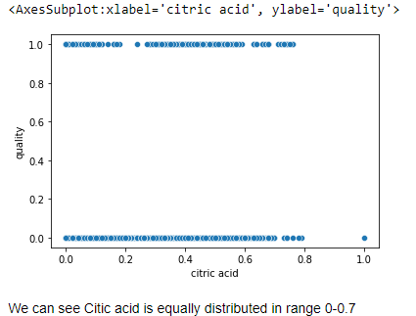

sns.scatterplot(x="residual sugar", y="quality", data=red_proj)

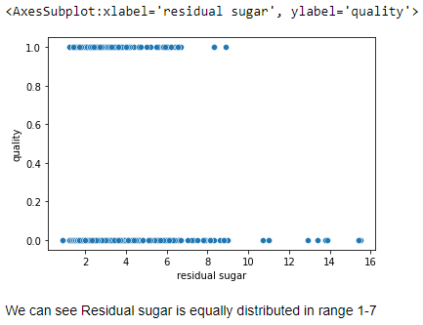

sns.scatterplot(x="chlorides" ,y="quality", data=red_proj)

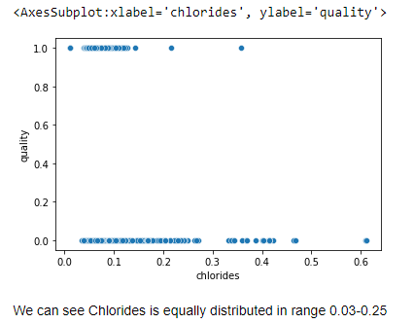

sns.scatterplot(x="free sulfur dioxide", y="quality", data=red_proj)

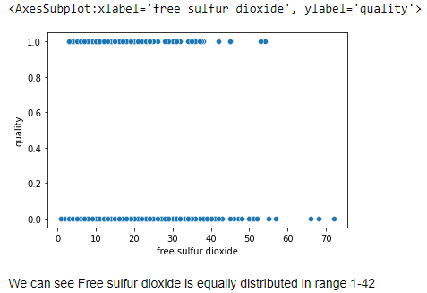

sns.scatterplot(x="total sulfur dioxide", y="quality" ,data=red_proj)

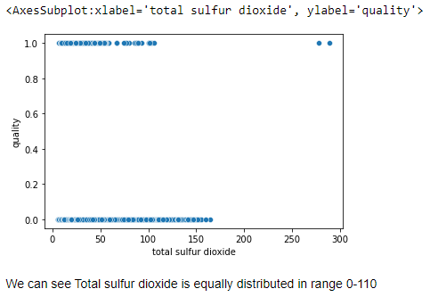

sns.scatterplot(x="density", y="quality", data=red_proj)

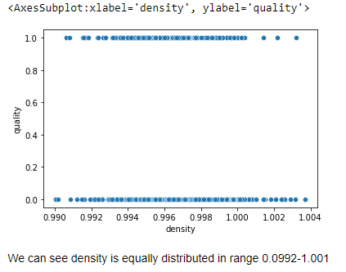

sns.scatterplot(x="pH", y="quality", data=red_proj)

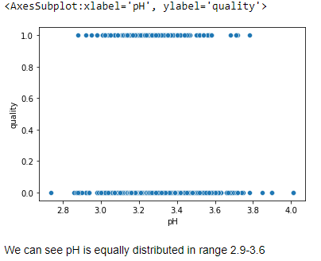

sns.scatterplot(x="sulphates", y="quality", data=red_proj)

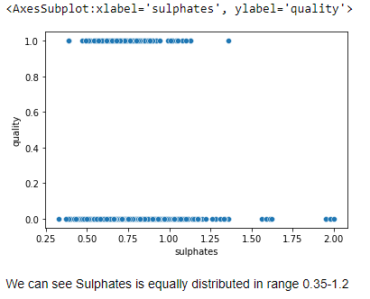

sns.scatterplot(x="alcohol", y="quality", data=red_proj)

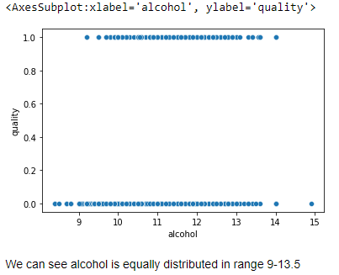

snscountplot(x =”quality”, data=red_proj

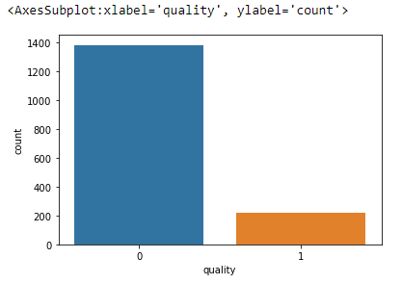

* **Correlation:**

red_proj.corr()

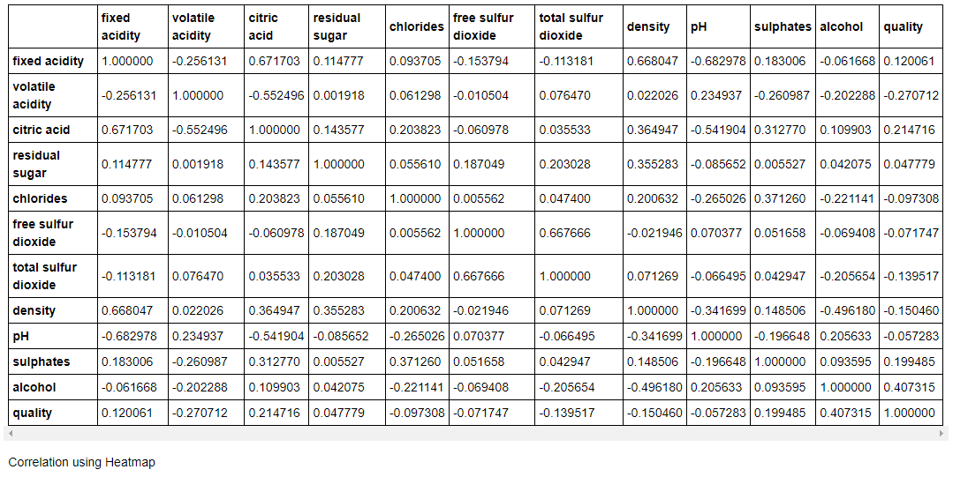

plt.figure(figsize=(15,10))

sns.heatmap(red_proj.corr(), annot=**True**, linewidth=0.5, linecolor='green',

fmt='.2f')

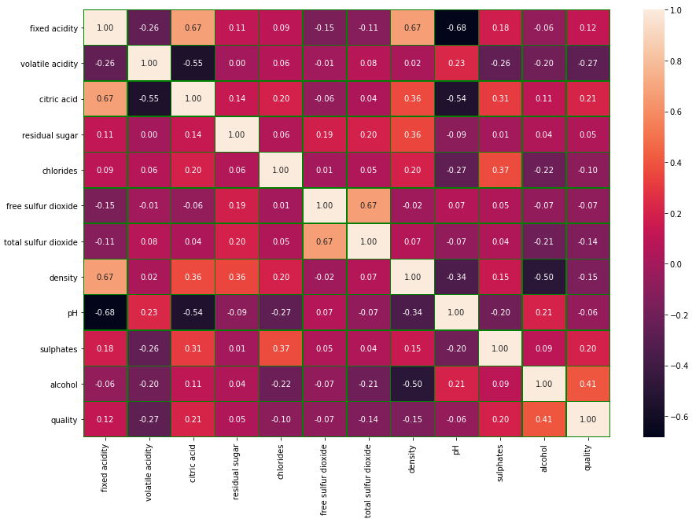

* **Outcome Of Correlation:**

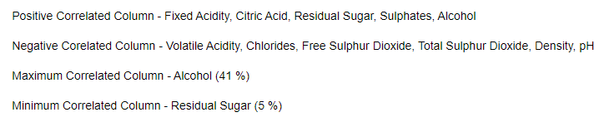

* **Describing Dataset:**

***# Get data in statistics form.***

***red_proj.describe()***

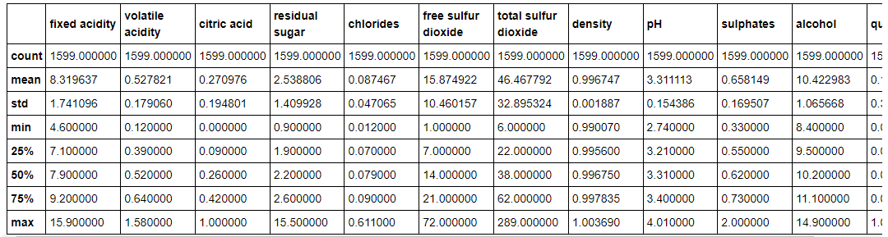

plt.figure(figsize=(18,24))

sns.heatmap(round(red_proj.describe()[1:].transpose(),2), linewidth=1, annot=**True**, fmt='f')

plt.xticks(fontsize=15)

plt.yticks(fontsize=10)

plt.title("Variables Summary")

plt.show()

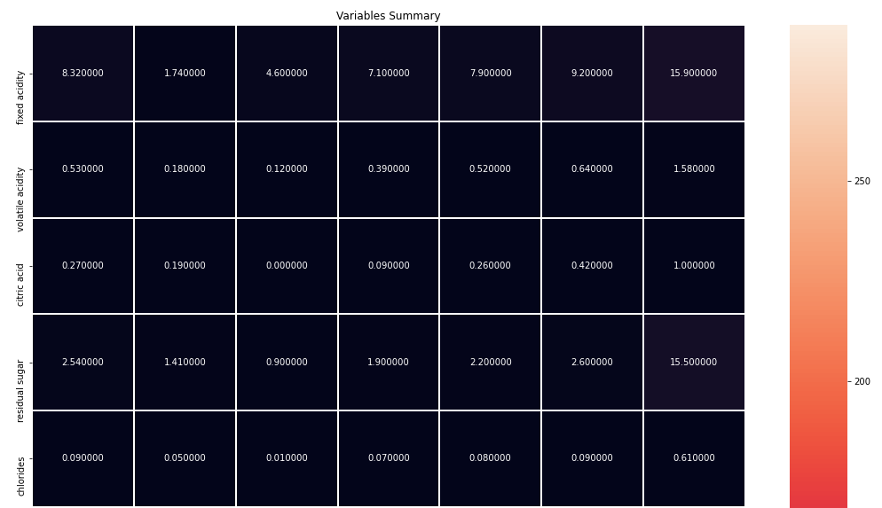

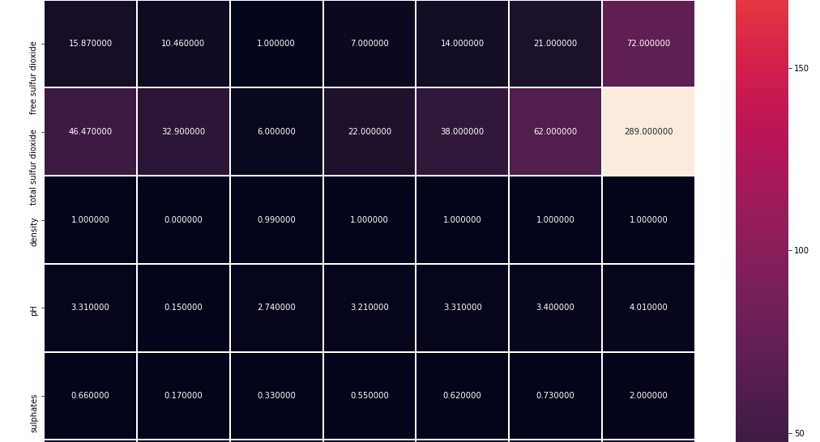

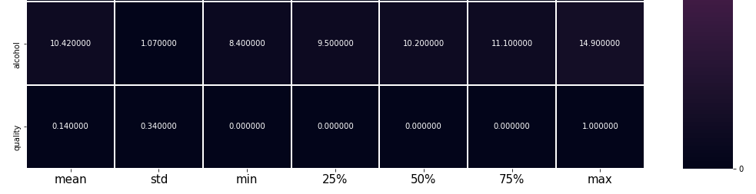

* **Dataset Outcome:**

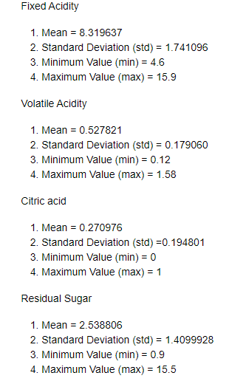

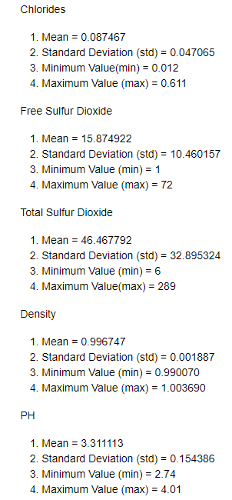

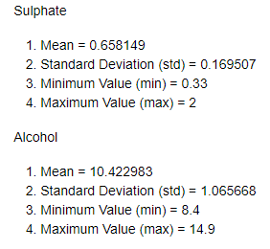

red_proj.info()

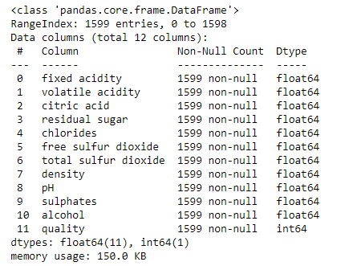

* **Outlier Checking:**

collist = red_proj.columns.values

ncol = 30

nrows = 15

plt.figure(figsize=(ncol,3*ncol))

**for** i **in** range(0,len(collist)):

plt.subplot(nrows,ncol,i+1)

sns.boxplot(red_proj[collist[i]], color='green', orient='v')

plt.tight_layout()

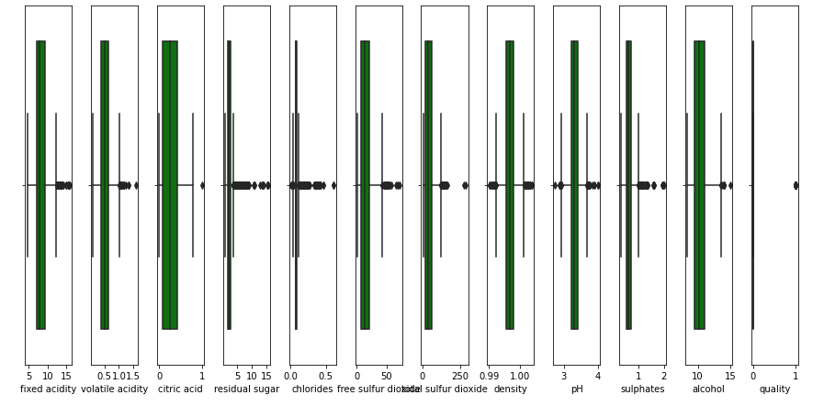

red_proj["quality"].unique()



# Checking the skewness in the given dataset

red_proj.skew()

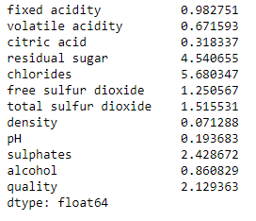

***# Get a count of number of survivors on Titanic***

Titanic['Survived'].value_counts()

0 549

1 342

Name: Survived, dtype: int64

***# Visualize the count of number of survivors***

sns.countplot(Titanic['Survived'])

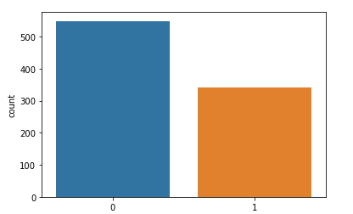

***# Let's find out the mean values of survivors with different group***

titanic=Titanic.groupby('Survived').mean()

print(titanic)

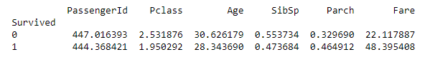

In the above outcome we can see that the fare cost of survived people was average 48.39

* **SOME KEY-OBSERVATIONS FROM THE ABOVE COLLECTED STATISTICAL DATA :**

1.Missing values found in the columns "Age" and "Cabin".

2.Around 38% of passengers have survived.

3.Also we need to change convert some objects to integers for a proper analysis.

4.Removing some Non-correlated data will help in efficient data analysis.

* **EXPLORATORY DATA ANALYSIS(EDA)/ DATA EXPLORATION**

plt.figure(figsize=(15,25))

sns.set_style("whitegrid")

plt.subplot(3,3,1)

sns.countplot(Titanic["Survived"]).set_title("survivors")

plt.subplot(3,3,2)

sns.set_style("whitegrid")

sns.countplot(x="Survived",hue="Sex",data=Titanic,palette="rainbow").set_title("Survivors among Male and Female")

plt.subplot(3,3,3)

sns.set_style("whitegrid")

sns.countplot(x="Survived",hue="Pclass",data=Titanic,palette="rainbow").set_title("survivors vs class")

plt.subplot(3,3,4)

sns.set_style("whitegrid")

sns.countplot(x="Survived",hue="Embarked",data=Titanic,palette="rainbow").set_title("Survivors vs Embarked")

plt.subplot(3,3,5)

sns.set_style("whitegrid")

sns.countplot(x="Embarked",hue="Sex",data=Titanic,palette="rainbow").set_title("survivors vs Sex")

plt.subplot(3,3,6)

sns.set_style("whitegrid")

sns.barplot(x="Sex",y="Survived",hue="Pclass",data=Titanic,palette="rainbow").set_title("survivors w.r.t class & Sex")

plt.subplot(3,3,7)

sns.set_style("whitegrid")

sns.barplot(x="Sex",y="Survived",hue="Embarked",data=Titanic,palette="rainbow").set_title("survivors w.r.t Embarked & Sex")

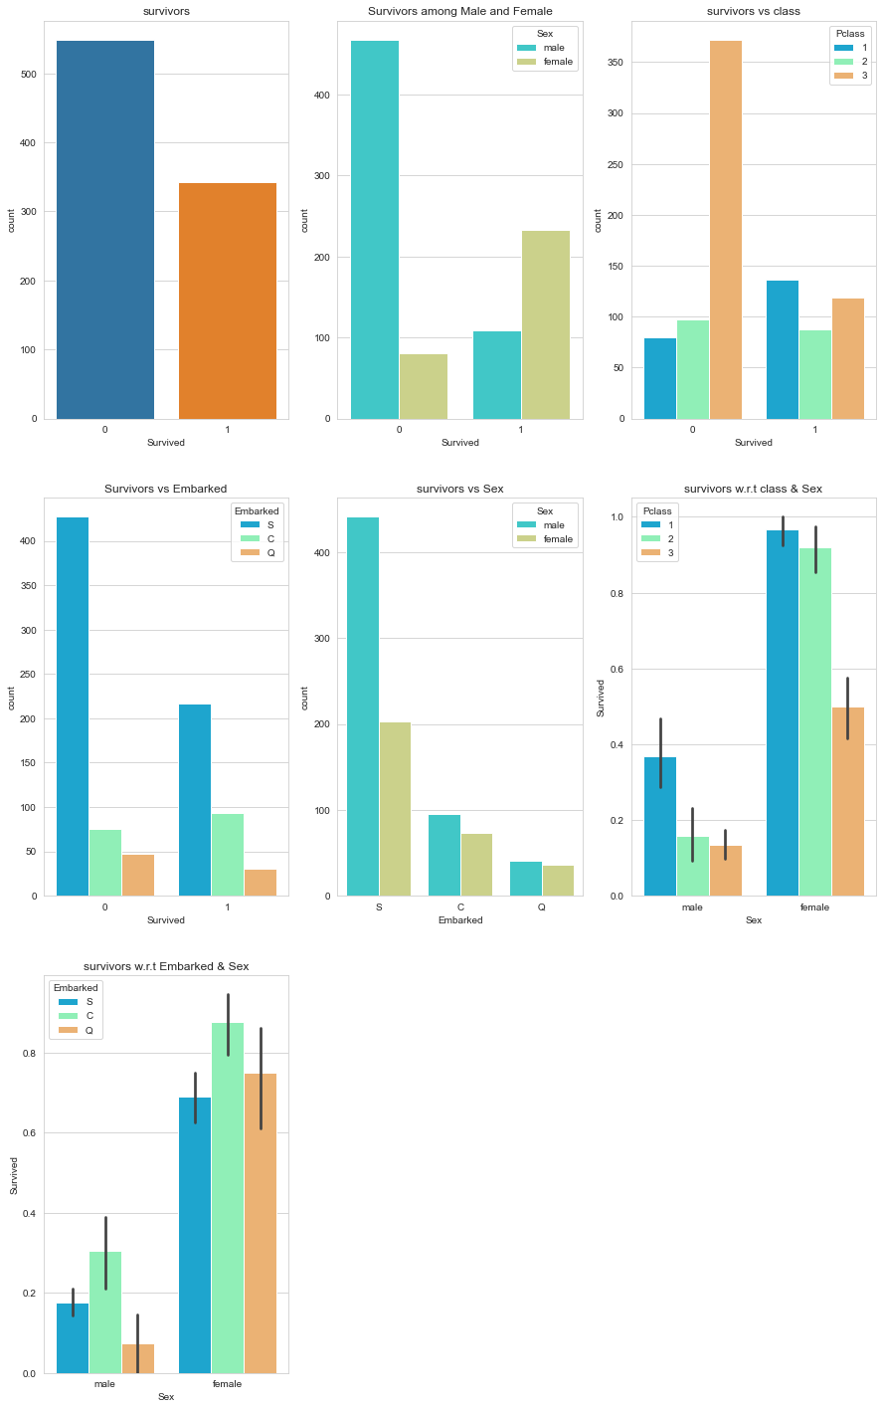

**FROM THE ABOVE PLOTTED GRAPHS:**

1. We can see that the number of survivors is very less compared to the died.

2. Women have a higher survival rate compared to men.

3. Women from the 1st class seems to have survived a lot compared to all other classes.

4. The mortality rate for 3rd class passengers is high across all genders.

5. The passengers embarked from 'Port S' have a higher survival rate compared to all other ports.

6. Also the mortality rate for the 'Port S' is high compared to all other ports.

7. Most of the passengers are men who have embarked from 'Port S'.

8. Most of the passengers form 1st class are women. Thus we observe that Sex have higher relation with survived passengers. But we can find that the attribute sex is object, so we will convert it into integer data type. So up next, we will change the sex data type and also replacing Null values with mean value in Age column will give us a solid Dataset to work with.

***#checking for Null values***

Titanic.isnull().sum()

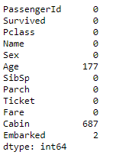

Here we can see that column Age and Cabin have null values. Here we can replace null value of Age with mean of age. And drop the column as it is of no use.

***#findind mean value for Age***

Titanic["Age"].mean()

29.69911764705882

***#replacing the mean value with NaN values in Age attribute***

Titanic["Age"].fillna(Titanic["Age"].mean(),inplace=**True**)

Titanic.isnull().sum()

PassengerId 0

Survived 0

Pclass 0

Name 0

Sex 0

Age 0

SibSp 0

Parch 0

Ticket 0

Fare 0

Cabin 687

Embarked 2

dtype: int64

***#dropping Cabin attribute since it has a lot of missing values***

Titanic.drop(["Cabin"],axis=1,inplace=**True**)

Titanic

Titanic.dropna(inplace=**True**)

Titanic.shape

(889, 11)

***#Checking Null Value again, if we have in any column***

Titanic.isnull().sum()

PassengerId 0

Survived 0

Pclass 0

Name 0

Sex 0

Age 0

SibSp 0

Parch 0

Ticket 0

Fare 0

Embarked 0

dtype: int64

Since we have no Null values in any of the given attributes, we can proceed with further data analysis.

***#UNIVARIATE ANALYSIS,BIVARIATE AND MULTI-VARIATE ANALYSIS***

sns.distplot(Titanic["Age"])

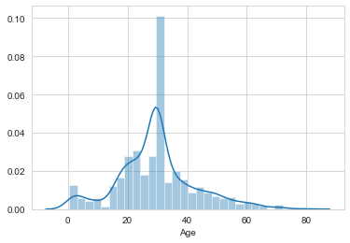

From the above data, we conclude that we have a normal distribution among Age.

***# Check the rate of survivors between male females and child***

Titanic.Sex=Titanic.Sex.map({"male":1, "female":0})

sns.distplot(Titanic["Sex"])

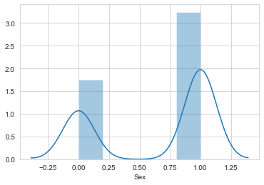

Male are higher than female among all the passengers.

sns.distplot(Titanic["Pclass"])

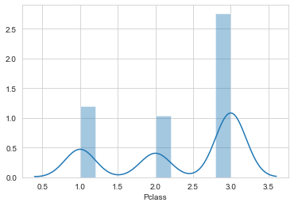

sns.pairplot(Titanic)

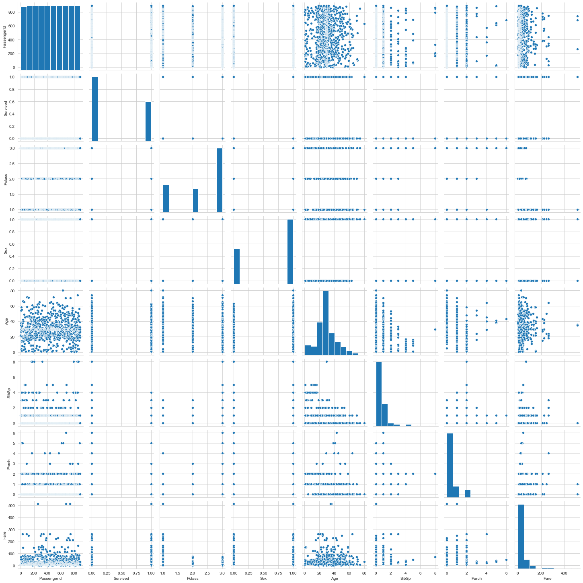

dfcor=Titanic.corr()

dfcor

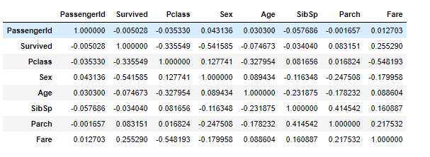

Many attributes such as Name, Fare, sibsb, tickets, pclass, embarked will have to be removed to check the accuracy of the given mode.

***#removing the unwanted attributes for this analysis.***

Titanic.drop(["Name","Fare","SibSp","Parch","Ticket","Pclass","Embarked"],axis=1,inplace=**True**)

Titanic.head()

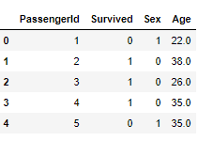

* **ANALYSING THE OUTLIERS.**

An outlier is an element of a data set that distinctly stands out from the rest of the data. In other words, outliers are those data points that lie outside the overall pattern of distribution. The easiest way to **detect outliers is to create a graph. Plots such as Box plots, Scatterplots and Histograms** **can help to detect outliers**. Alternatively, we can use **mean and standard deviation** to list out the outliers. Interquartile Range and Quartiles can also be used to detect outliers.

plt.figure(figsize=(20,20))

Titanic.plot(kind="box",subplots=**True**)

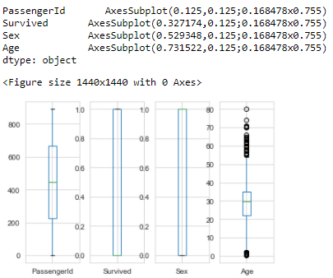

IT SEEMS "AGE" HAS LOT OF OUTLIERS PRESENT IN THEM. WE WILL HAVE TO REMOVE THE OUTLIERS FOR FURTHER PROCESS.

* **REMOVING THE OUTLIERS**

**from** **scipy.stats** **import** zscore

zs=np.abs(zscore(Titanic))

zs

array([[1.73250451, 0.78696114, 0.73534203, 0.59049493],

[1.72861124, 1.27071078, 1.35991138, 0.64397101],

[1.72471797, 1.27071078, 1.35991138, 0.28187844],

...,

[1.72471797, 0.78696114, 1.35991138, 0.00352373],

[1.72861124, 1.27071078, 0.73534203, 0.28187844],

[1.73250451, 0.78696114, 0.73534203, 0.18104628]])

threshold=3

Titanic_new=Titanic[(zs<3).all(axis=1)]

Titanic_new

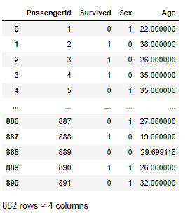

print(Titanic.shape)

print(Titanic_new.shape)

(889, 4)

(882, 4)

* **MODEL TRAINING**

In Machine Learning we create models to predict the outcome of certain events. To measure if the model is good enough, we can use a method called Train/Test.

**What is Train/Test?**

Train/Test is a method to measure the accuracy of your model. It is called Train/Test because you split the data set into two sets: a training set and a testing set.

* You train the model using the training set**.(Train the model means create the model.)**
* You test the model using the testing set.**(Test the model means test the accuracy of the model.)**

***#SEPERATING DEPENDENT AND IN-DEPENDENT VARIABLES***

x=Titanic_new.drop("Survived",axis=1)

y=Titanic_new["Survived"]

*#SPLITTING THE TESTING AND TRAINING DATAS*

**from** **sklearn.linear_model** **import** LogisticRegression

**from** **sklearn.metrics** **import** accuracy_score

**from** **sklearn.metrics** **import** confusion_matrix,classification_report

**from** **sklearn.model_selection** **import** train_test_split

x_train,x_test,y_train,y_test=train_test_split(x,y,test_size=.22,random_state=42)

x_train.shape

(687, 3)

y_train.shape

(687,)

x_test.shape

(195, 3)

y_test.shape

(195,)

* **FINDING ACCURACY OF THE GIVEN DATASET**

**Logistic Regression** is a Machine Learning classification algorithm that is used to predict the probability of a categorical dependent variable. In logistic regression, the dependent variable is a binary variable that contains data coded as 1 (yes, success, etc.) or 0 (no, failure, etc.). In other words, the logistic regression model predicts P(Y=1) as a function of X.

***#Logical Regression***

lr=LogisticRegression()

lr.fit(x_train,y_train)*#training*

lr_pre=lr.predict(x_test)*#testing*

print(lr_pre)

print("**\n**Accuracy : ",accuracy_score(y_test,lr_pre))

print("**\n**Confusion matrix : ",confusion_matrix(y_test,lr_pre))

print("**\n**classification report : ",classification_report(y_test,lr_pre))

[1 1 0 0 0 0 1 0 0 0 1 0 1 0 0 0 0 1 0 1 0 1 1 1 1 0 0 0 1 0 0 0 1 1 0 1 0

1 0 0 0 1 0 0 0 1 1 0 0 1 0 0 0 1 1 0 1 0 1 1 0 0 0 0 0 1 1 0 1 1 0 0 1 1

1 0 0 1 1 0 1 1 0 0 1 0 1 0 0 1 0 1 0 0 0 1 0 0 1 1 0 0 0 0 0 0 1 0 1 1 1

1 0 0 1 0 0 0 1 0 0 1 0 0 1 0 0 1 0 0 0 0 1 0 1 0 1 1 0 1 1 1 0 0 0 0 0 0

1 1 1 0 0 1 0 0 0 0 0 1 0 1 1 1 1 1 1 0 1 0 0 1 0 0 1 0 0 0 1 0 0 0 0 1 0

0 0 0 0 0 0 1 1 0 1]

Accuracy : 0.7948717948717948

Confusion matrix : [[99 23]

[17 56]]

classification report : precision recall f1-score support

0 0.85 0.81 0.83 122

1 0.71 0.77 0.74 73

accuracy 0.79 195

macro avg 0.78 0.79 0.78 195

weighted avg 0.80 0.79 0.80 195

**Random Forest** is a meta estimator that fits a number of classifying decision trees on various sub-samples of the dataset and uses averaging to improve the predictive accuracy and control over-fitting.

***#Random Forest Regressor Method***

**from** **sklearn.ensemble** **import** RandomForestRegressor

**from** **sklearn.model_selection** **import** cross_val_score

**from** **sklearn.metrics** **import** r2_score

rfr=RandomForestRegressor(criterion="mae",n_estimators=200)

rfr.fit(x_train,y_train)

rfr.score(x_train,y_train)

pre=rfr.predict(x_test)

pre

r2score=r2_score(y_test,pre)

cvs=cross_val_score(rfr,x_train,y_train,cv=5).mean()

print(f"Accuracy=**{**r2score*100**}**,cross_value_score=**{**cvs*100**}**,and difference=**{**(r2score*100)-(cvs*100)**}**")

Accuracy=28.521968335953307,cross_value_score=15.16563016636826,and difference=13.356338169585047

The **[Decision Trees](https://scikit-learn.org/stable/modules/tree.html" \l "tree)**is used to fit a sine curve with addition noisy observation. As a result, it learns local linear regressions approximating the sine curve.

*#DecisionTreeRegressor*

**from** **sklearn.tree** **import** DecisionTreeRegressor

**from** **sklearn.model_selection** **import** cross_val_score

**from** **sklearn.metrics** **import** r2_score

dcr=DecisionTreeRegressor(criterion="friedman_mse")

dcr.fit(x_train,y_train)

dcr.score(x_train,y_train)

pre=dcr.predict(x_test)

pre

r2score=r2_score(y_test,pre)

cvs=cross_val_score(dcr,x_train,y_train,cv=5).mean()

print(f"Accuracy=**{**r2score*100**}**,cross_value_score=**{**cvs*100**}**,and difference=**{**(r2score*100)-(cvs*100)**}**")

Accuracy=-35.75117898046258,cross_value_score=-36.937458264908564,and difference=1.1862792844459804

The **K** in the name of this classifier represents the **k nearest neighbors**, where **k is an integer** value specified by the user. Hence as the name suggests, this classifier implements learning based on the k nearest neighbors. The choice of the value of k is dependent on data.

***#KNeighbors Classifier***

**from** **sklearn.neighbors** **import** KNeighborsClassifier

knn=KNeighborsClassifier()

knn.fit(x_train,y_train)

knn_y=knn.predict(x_test)

print("Accuracy Score",accuracy_score(y_test,knn_y))

print("Confusion Matrix**\n**",confusion_matrix(y_test,knn_y))

print("Classification Report**\n**", classification_report(y_test,knn_y))

Accuracy Score 0.5435897435897435

Confusion Matrix

[[83 39]

[50 23]]

Classification Report

precision recall f1-score support

0 0.62 0.68 0.65 122

1 0.37 0.32 0.34 73

accuracy 0.54 195

macro avg 0.50 0.50 0.50 195

weighted avg 0.53 0.54 0.53 195

**Support vector machines (SVMs)** are a set of supervised learning methods used for [classification](https://scikit-learn.org/stable/modules/svm.html" \l "svm-classification), [regression](https://scikit-learn.org/stable/modules/svm.html" \l "svm-regression) and [outliers detection](https://scikit-learn.org/stable/modules/svm.html" \l "svm-outlier-detection).

The support vector machines in scikit-learn support both dense (numpy.ndarray and convertible to that by numpy.asarray) and sparse (any scipy.sparse) sample vectors as input. However, to use an SVM to make predictions for sparse data, it must have been fit on such data.

***#Support Vector Machine***

**from** **sklearn.svm** **import** SVC

**def** svmkernel(ker):

svc=SVC(kernel=ker)

svc.fit(x_train,y_train)

svc.score(x_train,y_train)

svc_y=svc.predict(x_test)

print("Accuracy Score",accuracy_score(y_test,svc_y))

print("Confusion Matrix**\n**",confusion_matrix(y_test,svc_y))

print("Classification Report**\n**", classification_report(y_test,svc_y))

svmkernel('rbf')

Accuracy Score 0.6256410256410256

Confusion Matrix

[[122 0]

[ 73 0]]

Classification Report

precision recall f1-score support

0 0.63 1.00 0.77 122

1 0.00 0.00 0.00 73

accuracy 0.63 195

macro avg 0.31 0.50 0.38 195

weighted avg 0.39 0.63 0.48 195

An **AdaBoost**  **classifier** is a meta-estimator that begins by fitting a **classifier** on the original dataset and then fits additional copies of the **classifier** on the same dataset but where the weights of incorrectly classified instances are adjusted such that subsequent **classifiers** focus more on difficult cases.

***#AdaBoostClassifier***

**from** **sklearn.ensemble** **import** AdaBoostClassifier

abc=AdaBoostClassifier()

abc.fit(x_train,y_train)

abc_y=abc.predict(x_test)

print("Accuracy Score",accuracy_score(y_test,abc_y))

print("Confusion Matrix**\n**",confusion_matrix(y_test,abc_y))

print("Classification Report**\n**", classification_report(y_test,abc_y))

Accuracy Score 0.8102564102564103

Confusion Matrix

[[99 23]

[14 59]]

Classification Report

precision recall f1-score support

0 0.88 0.81 0.84 122

1 0.72 0.81 0.76 73

accuracy 0.81 195

macro avg 0.80 0.81 0.80 195

weighted avg 0.82 0.81 0.81 195

**Gradient boosting** is a machine learning technique for regression and classification problems, which produces a prediction model in the form of an ensemble of weak prediction models, typically decision trees

***#GradientBoostingClassifier***

**from** **sklearn.ensemble** **import** GradientBoostingClassifier

gbc=AdaBoostClassifier()

gbc.fit(x_train,y_train)

gbc_y=gbc.predict(x_test)

print("Accuracy Score",accuracy_score(y_test,gbc_y))

print("Confusion Matrix**\n**",confusion_matrix(y_test,gbc_y))

print("Classification Report**\n**", classification_report(y_test,gbc_y))

Accuracy Score 0.8102564102564103

Confusion Matrix

[[99 23]

[14 59]]

Classification Report

precision recall f1-score support

0 0.88 0.81 0.84 122

1 0.72 0.81 0.76 73

accuracy 0.81 195

macro avg 0.80 0.81 0.80 195

weighted avg 0.82 0.81 0.81 195

On the basis of Accuracy score, the best model is done by Logical Regression, AdaBoostClassifier, GradientBoostingClassifier having accuracy b/w 75% -85%.

**GridSearchCV** implements a “fit” and a “score” method. It also implements **“score_samples”, “predict”, “predict_proba”, “decision_function”, “transform” and “inverse_transform”** if they are implemented in the estimator used.

The parameters of the estimator used to apply these methods are optimized by cross-validated grid-search over a parameter grid.

***#creating parameter list to pass in gridsearch CV***

param_grid_lr=[{"C":[0.001, 0.01, 0.05, 0.1, 0.5, 1.0, 10.0]}]

**from** **sklearn.model_selection** **import** GridSearchCV

GCV=GridSearchCV(lr,param_grid=param_grid_lr,scoring="accuracy",cv=10,refit=**True**,n_jobs=1)

GCV.fit(x_train,y_train)

GCV.best_estimator_

GCV_pred=GCV.best_estimator_.predict(x_test)

print("accuracy = ",r2_score(y_test,GCV_pred)*100)

accuracy = 12.418594206153166

**Joblib** is a set of tools to provide lightweight pipelining in Python. In particular:

1. transparent disk-caching of functions and lazy re-evaluation (memoize pattern)
2. easy simple parallel computing

**import** **joblib**

joblib.dump(lr,"titanic_survivor.pkl")

['titanic_survivor.pkl']

***#PREDICTING THE SURVIVAL RATE WITH A SAMPLE***

td=np.array([15,0,3.500])

td.shape

(3,)

td=td.reshape(1,-1)

td

array([[15. , 0. , 3.5]])

lr.predict(td)

array([1], dtype=int64)

* **TESTING THE MODEL WITH THE GIVEN DATA-SET**

i=np.array(y_test)

i

array([1, 1, 0, 0, 0, 1, 0, 0, 0, 1, 0, 0, 1, 0, 0, 0, 0, 0, 0, 1, 0, 1,

0, 1, 1, 0, 1, 0, 1, 1, 0, 0, 0, 0, 0, 1, 0, 1, 0, 0, 0, 0, 0, 0,

0, 0, 1, 0, 0, 1, 0, 0, 0, 1, 1, 1, 1, 0, 1, 1, 0, 1, 0, 0, 0, 1,

0, 0, 1, 1, 0, 0, 1, 0, 1, 0, 0, 1, 1, 0, 1, 1, 0, 1, 0, 0, 1, 0,

0, 1, 0, 1, 0, 0, 0, 1, 1, 0, 1, 1, 0, 0, 0, 0, 0, 0, 0, 0, 1, 0,

1, 0, 0, 0, 1, 0, 0, 0, 1, 0, 1, 0, 1, 1, 0, 0, 1, 0, 1, 0, 0, 0,

0, 0, 0, 0, 1, 1, 0, 1, 0, 0, 1, 0, 0, 0, 1, 0, 1, 1, 1, 0, 0, 1,

0, 1, 0, 0, 0, 1, 0, 1, 1, 1, 1, 0, 1, 0, 1, 0, 0, 1, 0, 0, 1, 0,

0, 0, 1, 0, 0, 1, 0, 1, 0, 0, 0, 0, 0, 0, 0, 0, 1, 0, 1],

dtype=int64)

df_com=pd.DataFrame({"original":i,"predicted":pre},index=range(len(i)))

df_com

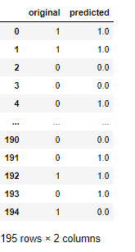

* **SAVING THE BEST MODEL**

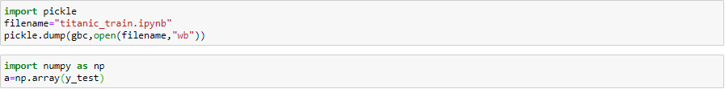

* **CONCLUSION:**

THE ABOVE OBSERVATIONS SHOW THAT THE MODEL HAS PREDICTED THE VALUES WITH AN ACCURACY OF 75-85%

AND, THE SURVIVAL RATE OF WOMEN’S ARE MORE THAN MEN’S.